24-678: Computer Vision for Engineers

Ryan Wu

ID: weihuanw

PS1 Report

Due: Sep 16 2023

This file contains the following:

PS1-2 Read color images, apply thresholding, and change colors

* grayscale image files: “circuit_grayscale.png” and “crack_grayscale.png”
* binary image files: “circuit_binary.png” and “crack_binary.png”
* output image files: “circuit_output.png” and “crack_output.png”
* readme.txt
* source code file(s) (attached to the end)

PS1-3 Gamma correction

* gamma-corrected images: “smiley_gcorrected.jpg” and “carnival_gcorrected.jpg”
* readme.txt includes
* source code file(s) (attached to the end)

**PS1-2 Grayscale**

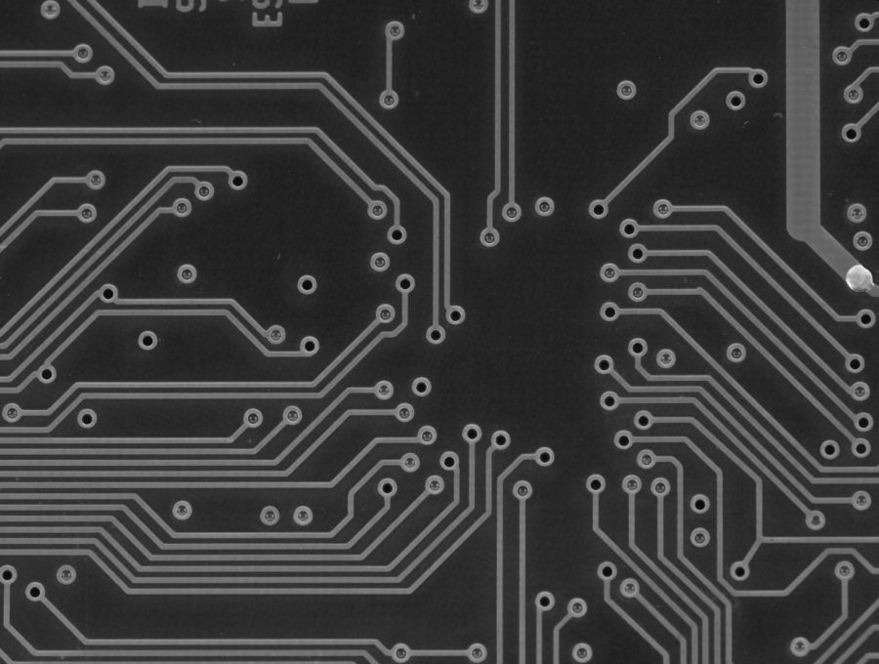

Figure . Circuit grayscale image.

**PS1-2 Grayscale**

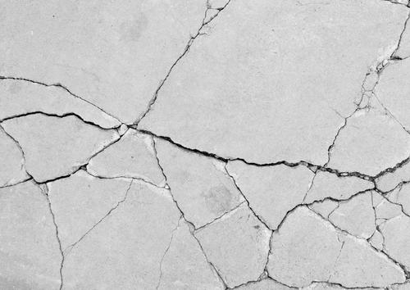

Figure . Crack grayscale image.

**PS1-2 Binary**



Figure . Circuit binary image.

**PS1-2 Binary**

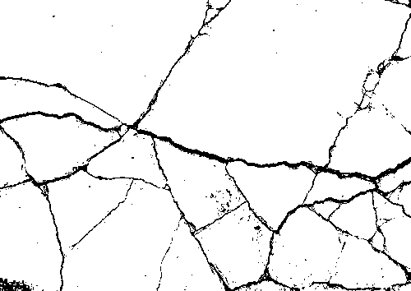

Figure . Crack binary image.

**PS1-2 Output**

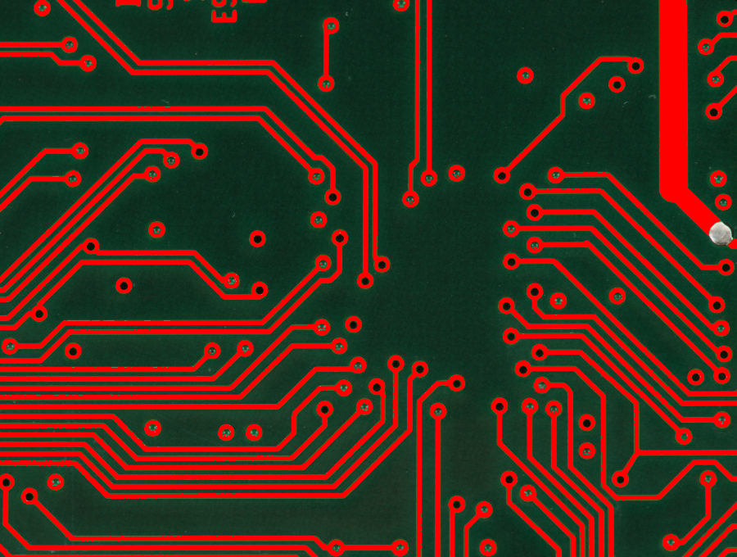

Figure . Circuit output color image.

**PS1-2 Output**

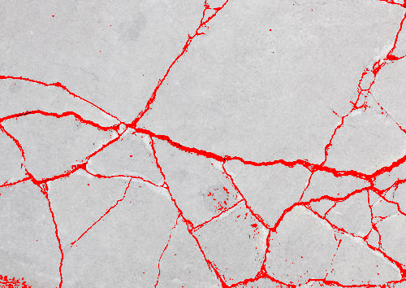

Figure . Crack output color image.

**PS1-2 Read me text file**

24-678: Computer Vision for Engineers

Ryan Wu

ID: weihuanw

PS1-2 Read color images, apply thresholding, and change colors

Operating system: macOS Ventura 13.5.2

IDE you used to write and run your code: PyCharm 2023.1.4 (Community Edition)

The number of hours you spent to finish this problem: 12 hours.

**PS1-3 Gamma correction**

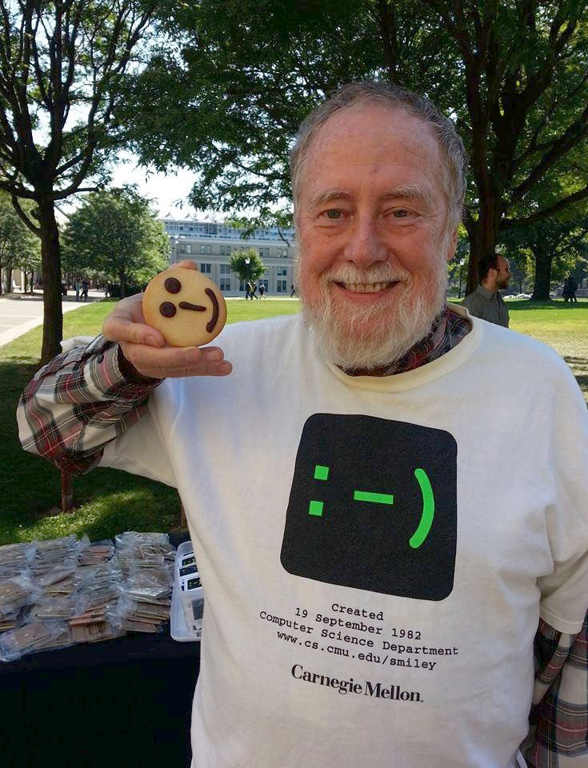

Figure . Smiley with gamma correction.

**PS1-3 Gamma correction**

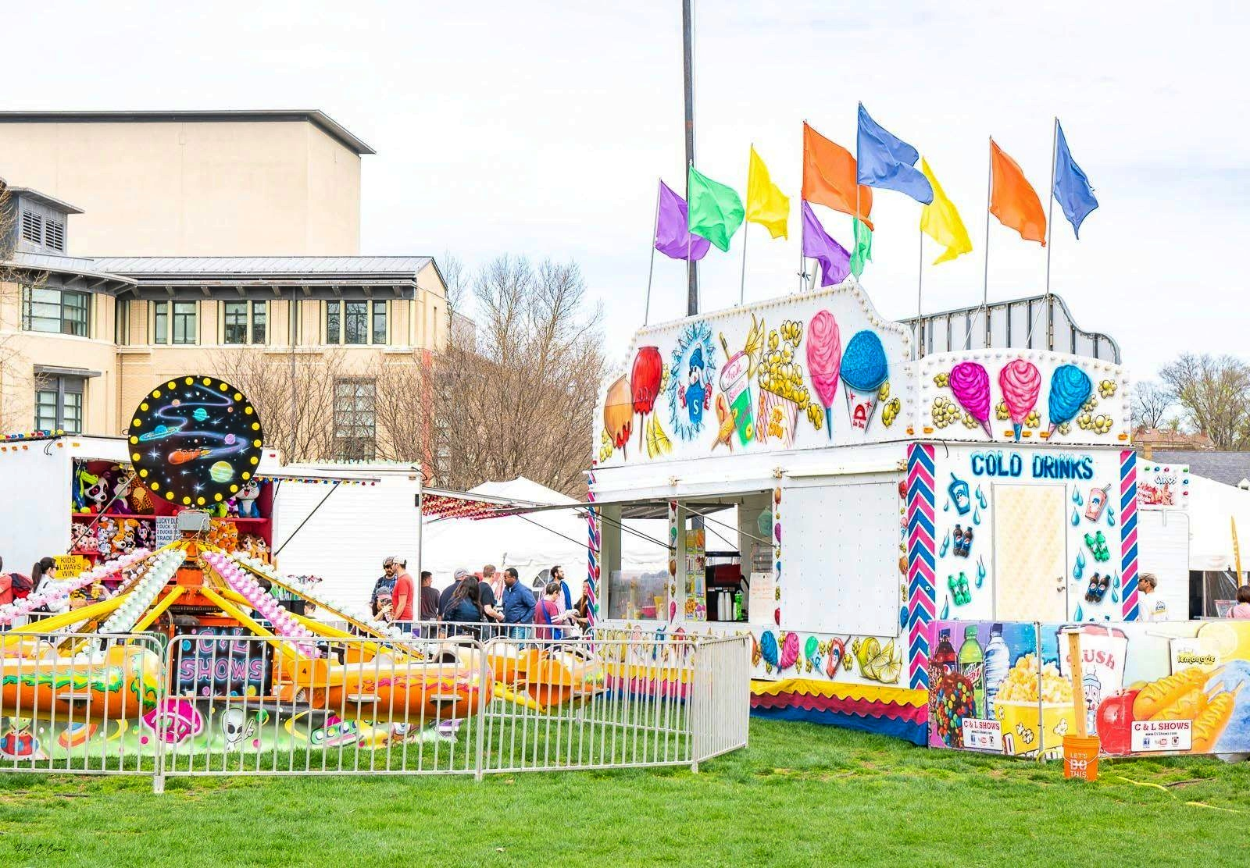

Figure . Carnival with gamma correction.

**PS1-3 Read me text file**

24-678: Computer Vision for Engineers

Ryan Wu

ID: weihuanw

PS1-3 Gamma correction

Operating system: macOS Ventura 13.5.2

IDE you used to write and run your code: PyCharm 2023.1.4 (Community Edition)

The number of hours you spent to finish this problem: 5 hours.